SOLUTION
PROBLEM IN LECTURE NOTES (Session 10-65)

Re. 1  ABC confounded |  | Re. 2  AB confounded
B1 | B2 | B1 | B2
(1) = -3  ab = 2  ac = 2  bc = 1 | a = 0  b = -1  c = -1  abc = 6 | (1) = -1  c = 0  ab = 3  abc = 5 | a = 1  b = 0  ac = 1  bc = 1
Problem: Determine 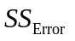directly!
a. 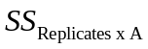:
 | Re. 1 | Re. 2
A+ | a ab  ac abc | a ab  ac abc
A- | (1) b  c bc | (1) b  c bc
Numerical results:

 | Re. 1 | Re. 2
A+ | 0 2  2 6 | 1 3  1 5 | 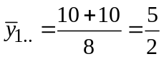
A- | -3 -1  -1 1 | -1 0  0 1 | 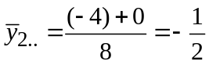
 | 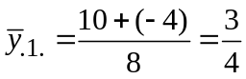 | 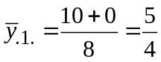 | 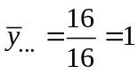
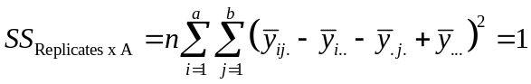
b. Similarly, 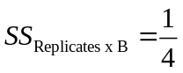 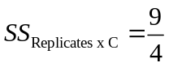
c. 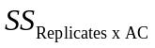:
 | Re. 1 | Re. 2
AC+ | (1) ac  b abc | (1) ac  b abc
AC- | a c  ab bc | a c  ab bc
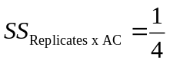
d. Similarly, 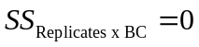 (This result can be derived immediately from the fact that 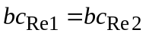)
Hence, 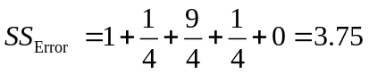

Note: AB and ABC appear in only 1 replicate (AB in replicate 1, ABC in replicate 2) No interaction exists between replicates and these effects.

